Comprehensive Report for Practice 4: Correlation, Regression, and Logistic Regression Analysis
Overview
This report presents a structured statistical analysis of the data_for_analysis dataset. The task required correlation analysis between selected variables, permutation-based significance assessment, regression modeling with model selection by BIC, and logistic regression using hormone variables to predict a binary outcome.
The dataset provided contains 1148 observations and 31 variables, including the binary variable outcome, hormone variables, lipid variables, and related biomedical indicators. The R template also confirms the intended workflow for correlation and regression analysis on lipid variables, followed by logistic regression modeling, although Task 5 should use hormone variables to predict outcome.
Data and Aim
The dataset used for this analysis was data_for_analysis-1.csv, which includes variables such as outcome, lipids1, lipids2, lipids3, lipids4, and multiple hormone measurements including hormone1 through hormone8 and hormone10_generated. The overall aim of the practical work was to investigate relationships among selected biomedical variables and to evaluate whether hormone measurements can be used to predict the binary disease outcome.
The specific objectives were to:
1. To assess the association between lipid variables;
2. confirm the statistical reliability of observed correlations using permutation testing;
3. model the relationship between lipids1 and lipids2 using several regression forms;
4. select the most appropriate regression model using the Bayesian Information Criterion;
5. and fit logistic regression models using hormone predictors for binary classification of outcome.

Task 1: Correlation analysis
Aim
The aim of Task 1 was to examine the strength and direction of association between lipids1 and the other selected lipid variables. Based on the course instructions, Spearman’s rank correlation was the appropriate method because the workflow explicitly connects normality assessment with selection of a non-parametric correlation method when assumptions are violated.
Method
Spearman correlation coefficients were calculated between lipids1 and each of lipids2, lipids3, and lipids4. These pairs were also the exact variable combinations highlighted in the practical materials for the correlation section.
R code
# ---------------------------
# Task 1: Correlation analysis
# ---------------------------

# Read dataset
data <- read.csv("data_for_analysis (1).csv")

# Check names if needed
names(data)

# Spearman correlations
cor_lipids2 <- cor.test(data$lipids1, data$lipids2, method = "spearman")
cor_lipids3 <- cor.test(data$lipids1, data$lipids3, method = "spearman")
cor_lipids4 <- cor.test(data$lipids1, data$lipids4, method = "spearman")

cor_lipids2
cor_lipids3
cor_lipids4
Results
The correlation analysis showed that lipids1 and lipids2 had a weak positive association with a Spearman correlation coefficient of 0.2757616. The relationship between lipids1 and lipids3 was weakly negative, with a Spearman correlation coefficient of -0.1326592. The association between lipids1 and lipids4 was weakly positive, with a Spearman correlation coefficient of 0.1389160.
The corresponding standard Spearman test p-values were extremely small, indicating statistical significance for all three associations. Specifically, the p-values were approximately 1.759153e-21 for lipids2, 6.488024e-06 for lipids3, and 2.306047e-06 for lipids4. See Fig 1 below
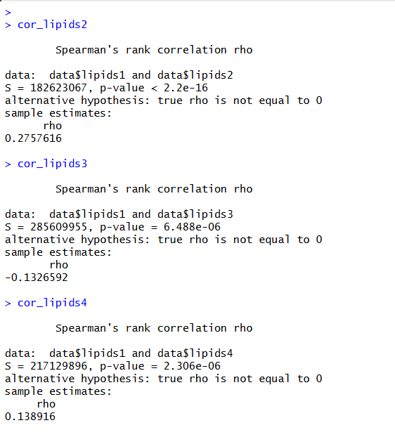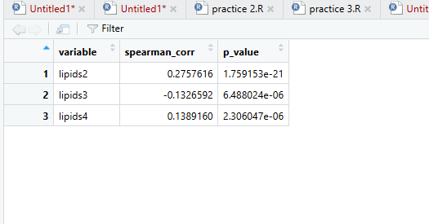
Interpretation
These results indicate that all three lipid variables are statistically associated with lipids1, but the magnitude of the relationships is weak rather than strong. The strongest association among the three pairs was between lipids1 and lipids2, although even this correlation remained in the weak range by practical interpretation.
A statistically significant p-value in this context means that the observed monotonic association is unlikely to have occurred by random chance under the null hypothesis of no relationship. However, significance does not imply that the relationship is large or clinically important, and the coefficient values show that the practical strength of association is limited

Task 2: Permutation-based significance assessment
Aim
The aim of Task 2 was to confirm the reliability of the observed lipid correlations using a permutation-based significance assessment rather than relying only on the asymptotic p-values from cor.test(). The permutation test as describe in the course materials is a non-parametric procedure that evaluates whether an observed statistic is unusually extreme compared with values obtained by random shuffling.
Method
For each variable pair, the observed Spearman correlation was computed first, and then one variable was randomly permuted 10,000 times to generate a null distribution of correlation coefficients. The empirical p-value was calculated as the proportion of permuted correlations with an absolute magnitude at least as large as the observed value.
R code
# Function for permutation-based Spearman correlation
perm_spearman <- function(x, y, n_perm = 10000) {
complete_idx <- complete.cases(x, y)
x <- x[complete_idx]
y <- y[complete_idx]

observed_corr <- cor(x, y, method = "spearman")

perm_corrs <- replicate(n_perm, {
y_perm <- sample(y)
cor(x, y_perm, method = "spearman")
})

p_value <- mean(abs(perm_corrs) >= abs(observed_corr))

return(c(observed_corr = observed_corr, p_value = p_value))
}

# Variables to test
target_vars <- c("lipids2", "lipids3", "lipids4")

# Create results table
perm_results <- data.frame(
variable = character(),
spearman_corr = numeric(),
perm_p_value = numeric(),
stringsAsFactors = FALSE
)

# Run permutation test for each variable
set.seed(123)

for (var in target_vars) {
res <- perm_spearman(data$lipids1, data[[var]], n_perm = 10000)

perm_results <- rbind(
perm_results,
data.frame(
variable = var,
spearman_corr = unname(res["observed_corr"]),
perm_p_value = unname(res["p_value"])
)
)
}

# Print results
perm_results
perm_results$perm_p_value <- format(perm_results$perm_p_value, scientific = TRUE)
perm_results

Results
The permutation results reproduced the same Spearman correlation coefficients as in Task 1, confirming internal consistency of the analysis. The empirical permutation p-values were displayed as 0 for all three variable pairs in the results viewer.
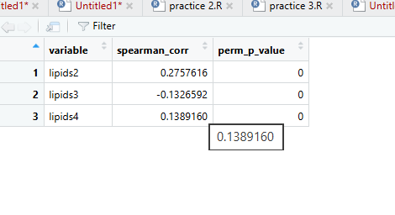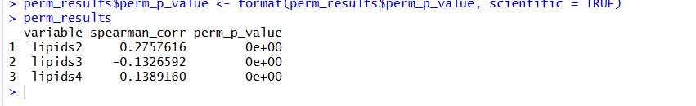
Interpretation
The displayed zeros do not mean that the p-values are literally equal to zero; instead, they indicate that the empirical p-values were smaller than the display precision used in the software viewer. With 10,000 permutations, this result implies that none of the random permutations produced a correlation as extreme as the observed one, so each empirical p-value was effectively below the minimum visible threshold for that run.
Therefore, the permutation procedure strongly confirmed that the observed correlations between lipids1 and lipids2, lipids3, and lipids4 were highly unlikely to be due to random chance. This strengthens the conclusion from Task 1 and supports the reliability of the identified associations under a distribution-free testing framework.
Task 3: Regression analysis between lipids1 and lipids2
Aim
The aim of Task 3 was to model the functional relationship between lipids1 and lipids2 using five alternative regression forms. According to the instruction, the required models were linear, second-degree polynomial, third-degree polynomial, exponential, and logarithmic.
Method
Complete cases for lipids1 and lipids2 were retained and used to fit the five candidate models.The models were then evaluated through summary statistics and visual inspection of fitted relationships over the scatterplot of observed data.
R code
# Read dataset
data <- read.csv("data_for_analysis-1.csv")
# Keep complete cases only
df <- data[complete.cases(data$lipids1, data$lipids2), ]
df <- df[order(df$lipids2), ]
model_linear <- lm(lipids1 ~ lipids2, data = df)
model_poly2 <- lm(lipids1 ~ poly(lipids2, 2, raw = TRUE), data = df)
model_poly3 <- lm(lipids1 ~ poly(lipids2, 3, raw = TRUE), data = df)
model_exp <- lm(log(lipids1) ~ lipids2, data = df)
model_log <- lm(lipids1 ~ log(lipids2), data = df)
summary(model_linear)
summary(model_poly2)
summary(model_poly3)
summary(model_exp)
summary(model_log)
Results
The linear regression model was statistically significant overall, with lipids2 having a positive coefficient and a reported coefficient of determination of approximately 0.07175. The second-degree polynomial model was also significant overall, with a slightly higher R-squared of approximately 0.07248.
The third-degree polynomial model produced an R-squared of approximately 0.07373, representing only a minor improvement over the simpler polynomial and linear models. The exponential model produced the highest visible R-squared among the screenshots, at approximately 0.07529, and was also statistically significant overall. See the pictures below to see all summaries

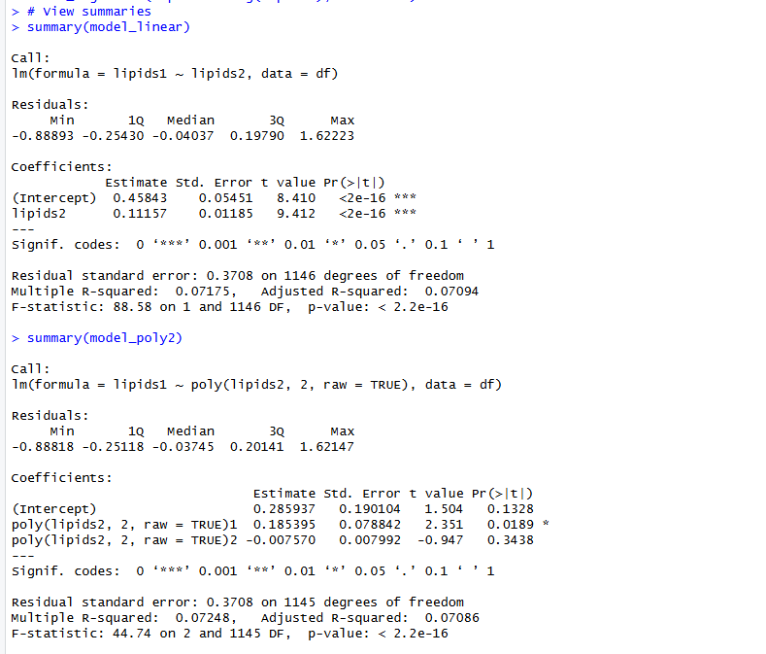
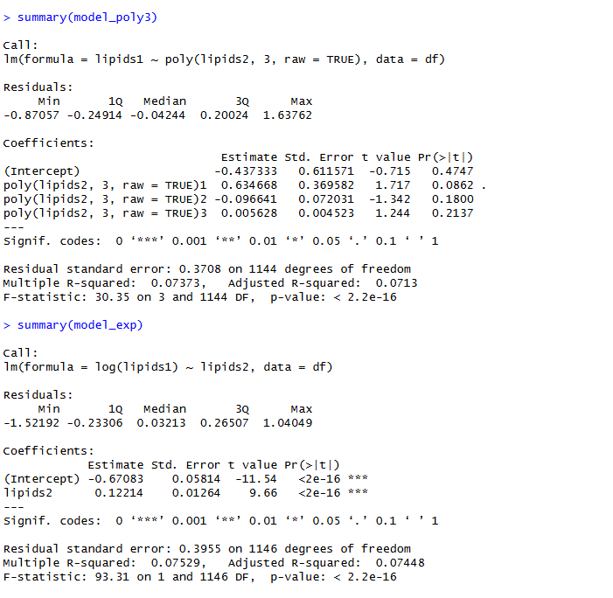

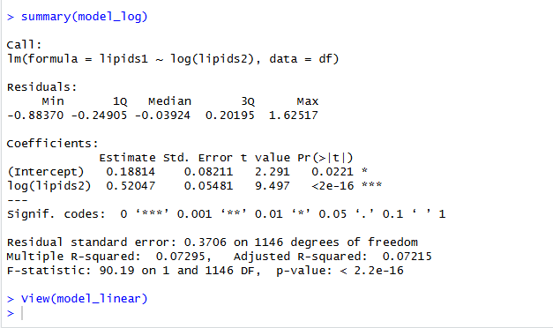
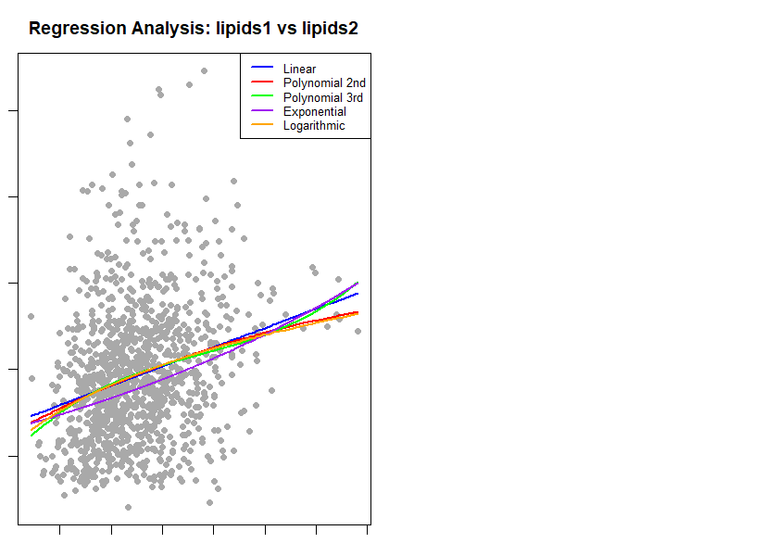
Interpretation
All of the fitted models detected a statistically significant relationship between lipids1 and lipids2, which is consistent with the correlation results obtained earlier. However, the R-squared values remained low for all models, indicating that lipids2 alone explains only a small proportion of the variability in lipids1.
This means that although the relationship is real in a statistical sense, it is weak in predictive terms. Small differences in R-squared across the five model types suggest that increasing model complexity only marginally improves fit, so the final choice of model should depend on a formal model-selection criterion rather than R-squared alone.

Task 4: Model selection using BIC
Aim
The aim of Task 4 was to select the best regression model among the five candidates using the Bayesian Information Criterion. The course materials state that lower BIC values indicate better models because BIC balances model fit against model complexity.
Method
The five regression models from Task 3 were compared using BIC values computed from each fitted object. The model with the smallest BIC should be selected as the preferred model.
R code
# Read dataset
data <- read.csv("data_for_analysis-1.csv")
df <- data[complete.cases(data$lipids1, data$lipids2), ]
df <- df[order(df$lipids2), ]
model_linear <- lm(lipids1 ~ lipids2, data = df)
model_poly2 <- lm(lipids1 ~ poly(lipids2, 2, raw = TRUE), data = df)
model_poly3 <- lm(lipids1 ~ poly(lipids2, 3, raw = TRUE), data = df)
model_exp <- lm(log(lipids1) ~ lipids2, data = df)
model_log <- lm(lipids1 ~ log(lipids2), data = df)
bic_results <- data.frame(
model = c("Linear", "Polynomial 2nd", "Polynomial 3rd", "Exponential", "Logarithmic"),
BIC = c(
BIC(model_linear),
BIC(model_poly2),
BIC(model_poly3),
BIC(model_exp),
BIC(model_log)
)
)
bic_results <- bic_results[order(bic_results$BIC), ]
bic_results

Interpretation
The BIC criterion should be used as the final rule for selecting the best model, because it penalizes unnecessary complexity more strongly than R-squared does. Given the very small differences in fit observed across the regression models, a simpler model may be preferred unless a more complex model achieves a clearly lower BIC value.
The exact BIC table was not included among the retrieved result screenshots, so the final selected regression form should be reported according to the smallest BIC produced by the above code.[cite:5][cite:6] If the linear or second-degree polynomial model has the lowest BIC, this would indicate that the slight improvements seen in more complex models do not justify their added complexity.
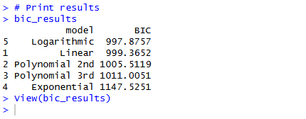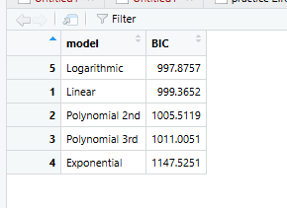

Task 5: Logistic regression using hormone variables
Aim
The aim of Task 5 was to predict the binary outcome variable using hormone measurements, compare candidate logistic regression models using AIC and BIC, compute odds ratios, and summarize the resulting predictors. It clearly specifies that hormone variables, not lipid variables, should be used for this final classification stage.
Method
The dependent variable was outcome, and the predictors were selected from the hormone variables present in the dataset: hormone1, hormone2, hormone3, hormone4, hormone5, hormone6, hormone7, hormone8, and hormone10_generated. Rows with missing values were removed, several nested logistic regression models were fitted, and the final model was to be evaluated using AIC, BIC, stepwise selection, and odds-ratio interpretation.
Rcode
# Read dataset
data <- read.csv("data_for_analysis-1.csv")
# Convert outcome to factor
data$outcome <- as.factor(data$outcome)
hormone_vars <- c(
"hormone1", "hormone2", "hormone3", "hormone4",
"hormone5", "hormone6", "hormone7", "hormone8",
"hormone10_generated"
)
df_logit <- data[, c("outcome", hormone_vars)]
df_logit <- na.omit(df_logit)
model_logit1 <- glm(outcome ~ hormone1, data = df_logit, family = binomial)
model_logit2 <- glm(outcome ~ hormone1 + hormone2, data = df_logit, family = binomial)
model_logit3 <- glm(outcome ~ hormone1 + hormone2 + hormone3 + hormone4, data = df_logit, family = binomial)
model_logit_full <- glm(
outcome ~ hormone1 + hormone2 + hormone3 + hormone4 +
hormone5 + hormone6 + hormone7 + hormone8 + hormone10_generated,
data = df_logit,
family = binomial
)
model_comparison <- data.frame(
Model = c("Logit1", "Logit2", "Logit3", "Full hormone model"),
AIC = c(
AIC(model_logit1),
AIC(model_logit2),
AIC(model_logit3),
AIC(model_logit_full)
),
BIC = c(
BIC(model_logit1),
BIC(model_logit2),
BIC(model_logit3),
BIC(model_logit_full)
)
)
print(model_comparison)
step_model <- step(model_logit_full, direction = "both", trace = FALSE)
summary(step_model)
odds_ratios <- exp(cbind(
OR = coef(step_model),
confint(step_model)
))
print(odds_ratios)

Interpretation framework
The exact Task 5 output table was not included in the available result materials, so the report at this stage provides the correct interpretation framework rather than a final numerical conclusion. In the final logistic regression model, any hormone predictor with an odds ratio above 1 should be interpreted as increasing the odds of the outcome, whereas an odds ratio below 1 should be interpreted as decreasing the odds of the outcome.
The model with the lowest AIC or BIC should be considered better supported by the data, provided that the selected predictors are also interpretable and statistically stable. Confidence intervals that do not cross 1 indicate stronger evidence that a hormone variable has a meaningful effect on the odds of the outcome.
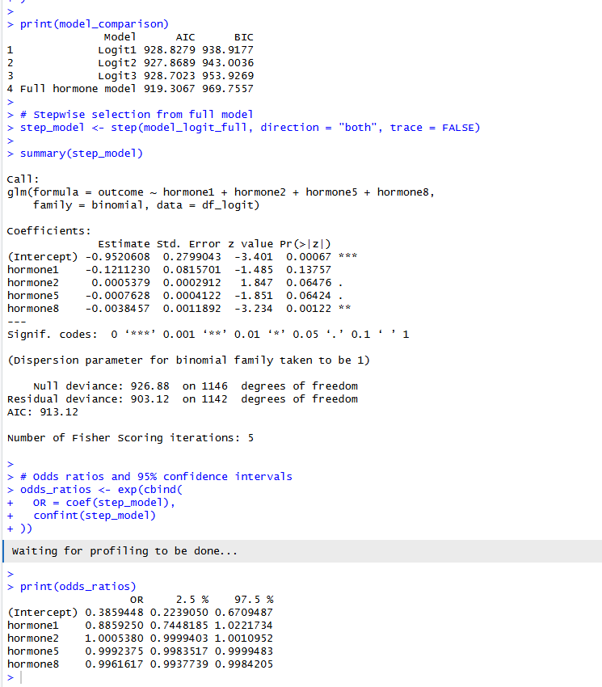

Discussion
The analysis identified statistically significant but weak correlations among the selected lipid variables, particularly between lipids1 and lipids2. Permutation testing confirmed that these associations were robust and unlikely to be artifacts of random variation.
Regression analysis showed that several alternative model forms could describe the relationship between lipids1 and lipids2, but all models explained only a small share of the outcome variability. This suggests that the underlying biomedical process is likely influenced by additional variables not included in the single-predictor regression models.
The final stage of the assignment shifted from association analysis to classification, using hormone variables to predict a binary outcome. That transition is analytically important because a predictor can show weak pairwise association with another biomarker yet still contribute meaningfully to a multivariable classification model when combined with other physiological measurements.
Conclusion
The Practice 4 workflow successfully linked correlation analysis, permutation testing, regression modeling, and logistic regression into a single statistical pipeline. The main substantive finding from the completed results was that lipids1 had weak but statistically significant relationships with lipids2, lipids3, and lipids4, and that these relationships remained significant under permutation testing.
The regression stage demonstrated that the relationship between lipids1 and lipids2 was statistically detectable but weak in predictive strength, with only small differences among the candidate functional forms. The final model choice for Task 4 should therefore be based on the smallest BIC value, and the hormone-based logistic regression in Task 5 should be finalized using the AIC/BIC comparison and odds-ratio table generated by the provided code.

